# Lean Agile Process Improvement

## Standard form for PIS

Every process improvement form has to be named in a way when you read the title itself you should be able to get some clarity on the changes proposed in that form.

Following is a standard form all Process Improvement Suggestion forms should include.

|  |  |
| --- | --- |
| **Suggested by** | your name |
| **Peer-reviewed by** | get your suggestion reviewed by at least 1 person as a prerequisite for approval. |
| **Reviewed and approved by** | This should be one of the following, CTO ( )  COO ()  Engineering Manager ( EM ) |

|  |  |
| --- | --- |
| **Problem** | Explain the problem as clearly as possible. |
| **Suggested solution** | Explain your solution as clearly as possible. |
| **Justifications (optional)** | This is completely optional. You can add more justifications into |
| **Does this problem impact WIP.?** | **YES** / **NO** |
| **If answer to the above question is yes, which project it is.?** |  |

## Decisions

**Problem** : QAs should know the impacted areas of the development when they recieve a bug-fixed version of. Such as database changes,

API changes, etc. These are mostly technical stuff.

**Solution** :

- Add this information as a comment to the story. The comment must have a defined structure covering all the information requirements (action item for [EM](mailto:Ammar.Ameerdeen@inivosglobal.com)).

- Additionally , the component field should be used to identify buggy components of the project in reports. Have to include this part into

the process and take it up in the next iteration of QA / Dev / BA sync this week (action item for [EM](mailto:Ammar.Ameerdeen@inivosglobal.com))

**Problem** : How to report and keep track of pre-UAT bugs (bugs in QA env).?

Solution : Report it exclusively with AIO. (action item for [EM](mailto:Ammar.Ameerdeen@inivosglobal.com) - Need to train the teams on AIO)

**Problem** : How to report and keep track of UAT bugs (bugs in staging)

Solution : Create a bug ticket in JIRA as the story is marked as done at this point. For UAT CRs, follow the standard story process.

**Problem** : How to report and keep track of Production bugs, hot fixes.?

Solution: Report this in a different board. This part of the process is yet to be defined (action item for [EM](mailto:Ammar.Ameerdeen@inivosglobal.com))

**Problem**: It should be possible to trace an issue when it appears in the production environment to where it originally had to be addressed. (We need to define this part - action item for [EM](mailto:Ammar.Ameerdeen@inivosglobal.com)). A tentative solution should be something like below.

Anything reported in the Production starts with the Bug reporting board. Attach the ticket in JSM to the respective epic and you can track it down to where it has gone wrong.

If it is in UAT or pre-UAT, the bug is attached to a story. The story must've gone through multiple dev/test cycles. We can do the tracing using AIO.

**Problem**: There are situations where we have to decide to move things out of sprint. But there has to be some control and monitoring over this.

Solution: Do triages. Introduce a process around this concept (action item for [EM](mailto:Ammar.Ameerdeen@inivosglobal.com))

### QA - 10/30/2023

**Problem** : QAs should know the impacted areas of the development when they recieve a bug-fixed version of. Such as database changes,

API changes, etc. These are mostly technical stuff.

**Solution** :

- Add this information as a comment to the story. The comment must have a defined structure covering all the information requirements (action item for [EM](mailto:Ammar.Ameerdeen@inivosglobal.com)).

- Additionally , the component field should be used to identify buggy components of the project in reports. Have to include this part into

the process and take it up in the next iteration of QA / Dev / BA sync this week (action item for [EM](mailto:Ammar.Ameerdeen@inivosglobal.com))

**Problem** : How to report and keep track of pre-UAT bugs (bugs in QA env).?

Solution : Report it exclusively with AIO. (action item for [EM](mailto:Ammar.Ameerdeen@inivosglobal.com) - Need to train the teams on AIO)

**Problem** : How to report and keep track of UAT bugs (bugs in staging)

Solution : Create a bug ticket in JIRA as the story is marked as done at this point. For UAT CRs, follow the standard story process.

**Problem** : How to report and keep track of Production bugs, hot fixes.?

Solution: Report this in a different board. This part of the process is yet to be defined (action item for [EM](mailto:Ammar.Ameerdeen@inivosglobal.com))

**Problem**: It should be possible to trace an issue when it appears in the production environment to where it originally had to be addressed. (We need to define this part - action item for [EM](mailto:Ammar.Ameerdeen@inivosglobal.com)). A tentative solution should be something like below.

Anything reported in the Production starts with the Bug reporting board. Attach the ticket in JSM to the respective epic and you can track it down to where it has gone wrong.

If it is in UAT or pre-UAT, the bug is attached to a story. The story must've gone through multiple dev/test cycles. We can do the tracing using AIO.

**Problem**: There are situations where we have to decide to move things out of sprint. But there has to be some control and monitoring over this.

Solution: Do triages. Introduce a process around this concept (action item for [EM](mailto:Ammar.Ameerdeen@inivosglobal.com))

### QA/BA - 11/03/2023

**Participants** : PM, QA Lead, EM

**Problem** : Need to identify on which sprint an API went to Clounote.

Solution :

 Custom field to set the API delivered sprint

**Problem** : Unable to create a board to manage clounote stuff.

Solution:

Migrate the project to company managed project.

Agreed on the below workflow.

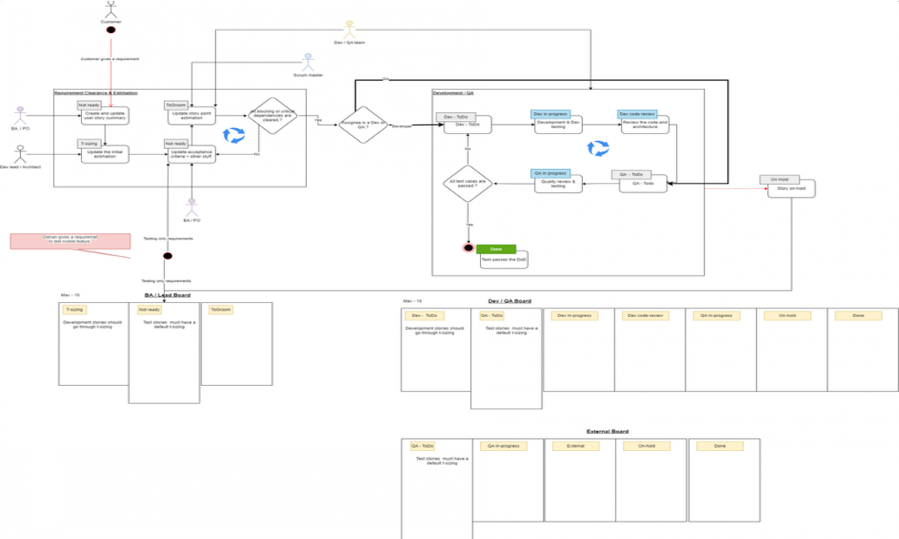

## Definition of a good change

1. Should not introduce or increase 7 types of lean wastes defined here. (this is highly important). Should decrease or eliminate one or more of these wastes from the process.



[7 Types of Lean Waste in software](https://inivos.atlassian.net/wiki/spaces/T/pages/115441665)

* 1. Refer -

1. If possible, should improve.
   1. Test coverage in a measurable manner.
2. The processes and artifacts should be monitorable through auto generated reports. These reports include
   1. Test coverage
   2. reports to measure post release bugs, etc.
3. The change should not break data related to reports currently in use.
4. Should not break the agile/scrum process related configurations. If does, the remedy should be included in your solution.

## Process Improvement Session - Agenda & Best Practices

Engineering manager goes through the evaluation criteria mentioned in the **DoGC** and the purpose of the session.

Each member gets 15 minutes to present their idea. You should go through **DoGC** criteria here → justify your proposal to the forum.



[Definition of a good change](https://inivos.atlassian.net/wiki/spaces/T/pages/112525331)

 You should explain how your suggestions help minimizing 7 types of lean waste introduced in a process. [n software](https://inivos.atlassian.net/wiki/spaces/T/pages/115441665)

[7 Types of Lean Waste i](https://inivos.atlassian.net/wiki/spaces/T/pages/115441665)

This ideally be an uninterrupted slot because we shouldn’t get to judgements without knowing the full idea well. If you have a question, you can raise the hand and the presenter gets to decide when to give time to answer your question.

The Engineering Manager takes notes.

After each member of the discussion presents their proposal a collab session is held for group discussions.

and

The Engineering manager goes through each suggestion and presents the evaluations against the criteria to the group. We still haven’t made a decision. This part of the session is there to drive the discussion toward an end and see if everyone is onboard.

The group takes a final decision. At this point it's a group decision and should be carried out that way. This is always and us vs our objectives discussion and decision.

## 7 Types of Lean Waste in software

7 types of wastes in software projects.

|  |  |  |
| --- | --- | --- |
| **In lean world** | **In the lean agile world** | **+ / - / =** |
| 1. Waste of inventory | partially done work (or work in process) |  |
| 2. Waste of over production | delivering extra or unneeded features |  |
| 3. Waste of extra processing | relearning |  |
| 4. Waste of transportation | handoffs |  |
| 5. Waste of waiting | delays |  |
| 6. Waste of motion | context switching |  |
| 7. Waste of defects | defects |  |

Tips to avoid waste

### Over production

1. validate assumptions in shorter cycles when it comes to all types of work.
2. do shorter cycles of quality assurance against development.

### Inventory (WIP)

1. Sprint plan is the scrum team’s WIP. Keep it within achievable limits.

### Extra processing

1. Practice good code documentation.
2. Document best practices.

### Handoffs

1. Encourage cross functional learning and activities. Such as dev-testing, test automation.
2. Keep your teams as self-sufficient as possible and eliminate repeating dependencies.

### Waiting Delays

1. Eliminate dependencies before taking a story into a sprint.
2. Remove bottlenecks in handoffs. (eg:- Dev → QA handoffs, QA → Dev handoffs)

### Motion (context switching)

1. Prioritize work really well in backlog reviews.
2. Avoid taking unplanned work in sprints.

### Defects

1. Work on quality up-front - Meaning, plan and write test cases in advance.
2. Keep Dev / QA cycles as short as possible by removing bottlenecks.